**Use Case:** *Rule selection*

**Id**: 1

**Level:** *Low*

**Description**

*The user can change the rule of simulation*

**Actor(s)**

*User, RuleList, Start Button, Canvas*

**Stakeholders and Interests**

*After the user selects the new rule and clicks the start button, the simulation should be displayed according to the new rule.*

**Pre-Conditions**

 *A ComboBox on GUI to select an available rule*  *A Canvas on GUI to display simulation*

 *A start button to start simulation*

**Trigger**

*The user clicked on the ComboBox for rules.*

**Post-Conditions**

*the simulation will be displayed according to the new rule.*

**Main Scenario**

*1. The user clicked on the ComboBox for rules*

*2. The user start a new simulation by start button*

**Rule 1:**

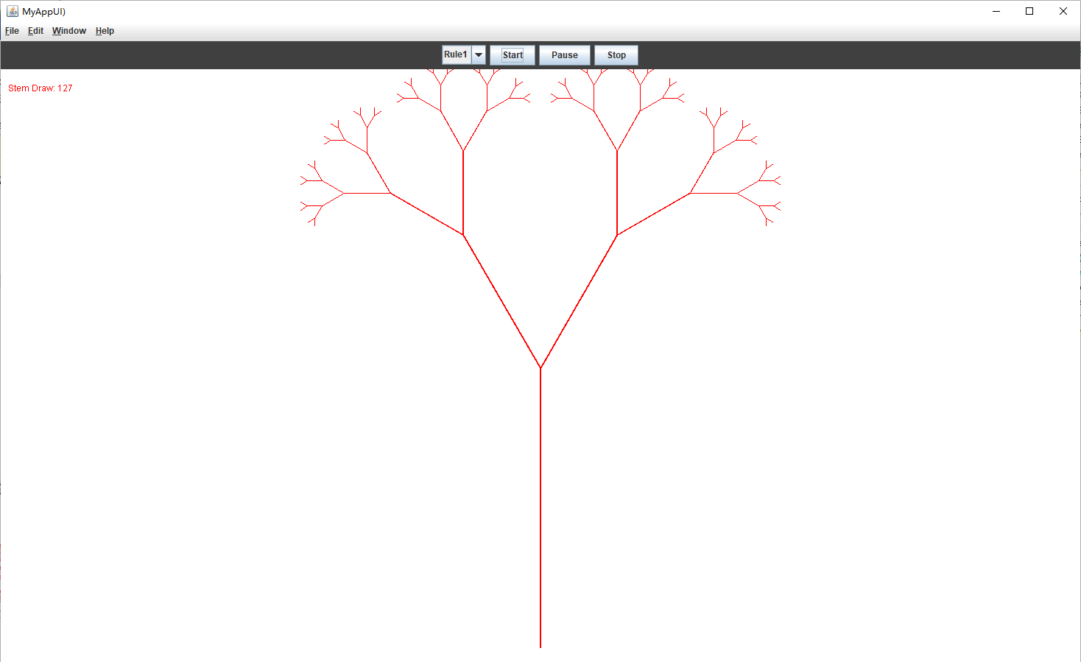

**Rule 2:**

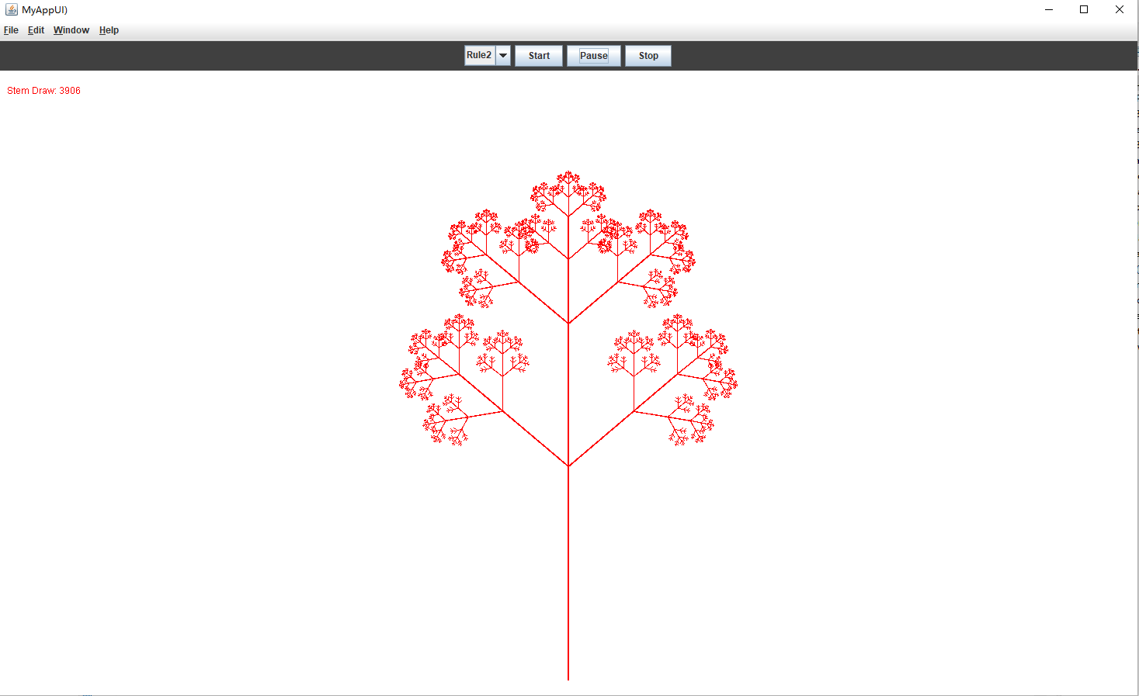

**Rule 3:**

